

# Dr Oliver Brown

Hello, my name is Olly Brown and I am the new Foundation Year 2 doctor starting at the practice. I am originally from South Cave and trained locally at the Hull York Medical School, graduating in 2017. Apart from my clinical work I am also academic doctor, which means I conduct clinical research alongside my medical training. I have an interest in cardiovascular medicine and the focus of my research over the last few years has been on patients with coronary artery disease and heart failure. I look forward to meeting some of you over the next four months.

Hello to all our patients and welcome to our second practice newsletter. We have so much news to tell you and will try to fit it all into this issue.

We hope you enjoy this newsletter and look forward to any comments, news or feedback you may want us to add to the next issue.

You can contact us by email via our practice website on

[hullccg.b81038-patientgroup@nhs.net](mailto:hullccg.b81038-patientgroup@nhs.net)

Alternatively please feel free to contact us by letter, telephone or in person at the practice.

We welcome your views, **your opinions matter**.

Inside This Issue

1. Welcome
2. Junior Doctors
3. Flu Season
4. Staff Training Days

And other closures

1. Patient DNA’s (Did Not Attends)
2. Prescriptions
3. Appointments
4. Blood Tests
5. Until Next time

We hope you enjoy this newsletter and look forward to receiving your feed back.

The Oaks Medical Centre

# Welcome to issue 6

volume 1 issue 2



August 2018

Open access flu clinic will take place on Saturday 6th October 8.30am - 12.00pm no appointment necessary.

There will be two further Flu clinic days during the week on Wednesday 10th October 12.30pm - 2.30pm and Friday 26th October 1pm - 4pm, no appointment necessary.

**6.Prescriptions**

In June and July there were 180 GP

and Nurses appointments that patients did not

keep or cancel. This amounts to approximately

35 hours of lost appointments ☹

Be considerate! if you are unable to attend your

Appointment, please contact the surgery as soon as

possible so it can be offered to another patient.

We also offer text message reminder service, if we have your correct mobile number you will receive a text reminder the day before, you can also cancel your appointment by replying to the text.

## 5.Patient DNA’s

Just a reminder, please allow at least 48 hours (2 full working days) for repeat prescriptions to be processed and up to 7 days for any

hospital treatment requests.

Please be aware we are closed on bank holidays.



# 3 Flu Season 2018

# 4.Closures

The next scheduled training days for the

practice are:

Wednesday 19th September, Tuesday 16th October,

And Thursday 15th November.

On these days we will close at 12.30pm

and reopen at 8am the following morning.

If you need medical advice during these times,

please dial 111.

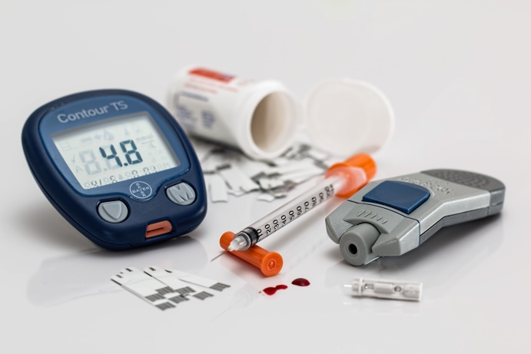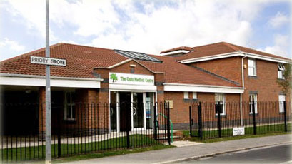

Thank you for taking the time to read this newsletter. Why not get involved more, and become one of our patient forum members, ask at reception for details.

**9.Until next time**

Please note if you have had a letter or a text to say you need a blood test with the health care assistant you can now book this on-line via our website, providing you have

Emis Online Access.

**8. Blood Tests**

# 7. Appointments

If You would like to discuss more than one issue with the GP please ensure you book a double appointment, this will prevent the GP running late

Oaks Medical Centre.