

My name is Jesal Acharya, I am an FY2 doctor recently started at the practice, I graduated for Imperial College London and completed the first year of my postgraduate training in Scunthorpe.

I have an interest is Neurology and hope to pursue that as a career. I enjoy music drama racquet sports and martial arts in my spare time.

I look forward to doing my best for you when I meet you.

# Dr Jesal Acharya

Hello. My name is Michael Pearce. I am one of the foundation year 2 doctors working at The Oaks Medical Centre for the next 4 months. I graduated from Manchester University Medical School in 2016 and I have worked in a variety of different departments including Colorectal/ General surgery, Pediatrics and General Medicine. I have enjoyed previous work in General Practice within community and am thinking of pursuing this with specialist interest in pediatrics.

# Dr Mike Pearce

Inside This Issue

1. Welcome
2. Junior Doctors
3. Flu Season
4. Staff Training Days

And other closures

1. Patient DNA’s (Did Not Attends)
2. Appointments
3. Patient Partner
4. Staff news
5. Until Next time

We hope you enjoy this newsletter and look forward to receiving your feed back.

Hello to all our patients and welcome to our third practice newsletter. We have so much news to tell you and will try to fit it all into this issue.

We hope you enjoy this newsletter and look forward to any comments, news or feedback you may want us to add to the next issue.

You can contact us by email via our practice website on

[hullccg.b81038-patientgroup@nhs.net](mailto:hullccg.b81038-patientgroup@nhs.net)

Alternatively please feel free to contact us by letter, telephone or in person at the practice.

We welcome your views, **your opinions matter**.

The Oaks Medical Centre

# Welcome to issue 3

volume 1 issue 3



8th August 2017

**6. Appointments**

# 4.Closures

Open access flu clinic will take place on Saturday 23rd September 8.30am - 12.15pm no appointment nessesary.

There will be two Flu clinic days Wednesday 4th October 12.30pm - 2.30pm and Friday 20th October 1pm - 4pm, to attend one of the clinic days please contact the surgery to book an appointment.

**PLEASE NOTE THIS IS ONLY FOR PATIENTS AT RISK OR OVER 65 YEARS OF AGE**

# 3 Flu Season 2017

The next scheduled training days for the

practice are:

Tuesday 12th September and Thursday 12th October.

On these days we will close at 12.30pm

and reopen at 8am the following morning.

If you need medical advice during these times,

please dial 111.

In May and June there were approximately 180 GP

and Nurses appointments that patients did not

keep or cancel. This amounts to approximately

35 hours of lost appointments ☹

Be considerate! if you are unable to attend your

Appointment, please contact the surgery as soon as

possible so it can be offered to another patient.

We also offer text message reminder service, if we have your correct mobile number you will receive a text reminder the day before, you can also cancel your appointment by replying to the text.

## 5.Patient DNA’s

Please note if you have more than one problem to discuss with the Doctor, you can request to book a double appointment by speaking to one of our receptionists.



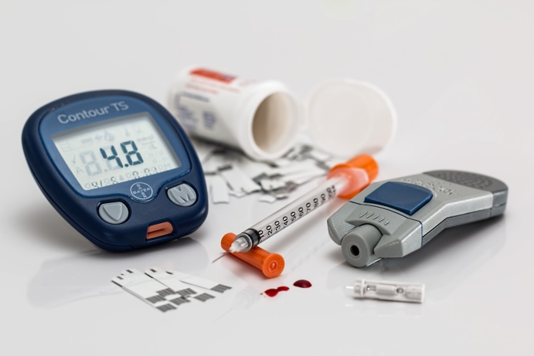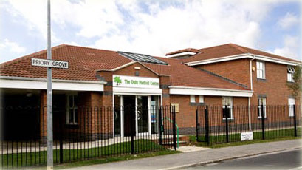

Thank you for taking the time to read this newsletter. Why not get involved more, and become one of our patient forum members, ask at reception for details.

**9. Until next time**

We would like to say Farwell to Julie Holland Assistant Practice Manager who has retired from the practice, and DR Clarke who has decided to make a move to Scotland.

The New Assistant Practice Manager is Julie Moran, who was previously a receptionist.

**8. Staff News**

If you need to make an appointment you can use our new automated telephone system to book, cancel, and check or change your appointments, the service is available 24 hours a day.

Patient Partner will go live on Monday 14th August.

# 7. Patient Partner

Oaks Medical Centre.